Chesapeake High School STEM Academy
School Progress Plan Summary 2023-2024
Amy Tyler, Principal
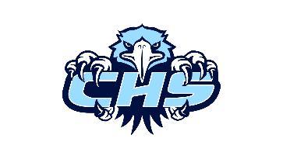

BCPS Vision: Baltimore County Public Schools will be among the highest performing school systems in the nation as a result of creating, sustaining, and investing in excellence for every student, every school, and every community. | School Mission: To provide rigorous, relevant, responsive and accessible academic and extra-curricular experiences through a STEM based culture that fosters 21st century skills.
ACTION STEPS
Mathematics and Literacy
Goal: All students will achieve mathematics proficiency as indicated by the MCAP assessment.

Goal: All students will achieve literacy proficiency as indicated by the MCAP assessment.
Action Step 1: Teachers will use a process for formative assessment including checks for understanding during instruction and adjusting teaching as needed based on student progress.
Action Step 2: Teachers will identify and implement appropriate scaffolds for instruction to promote student independence and to ensure students receiving special education services can access grade level content.

College and Career Readiness (CCR)
Goal: All students will be CCR by graduation.

Develop an aligned instructional system with resources and support necessary to keep on track on track to be CCR.
Action Step 1: Increase the number of students meeting the College and Career Readiness standard (based on SAT score in grade 11).
Action Step 2: Increase the percentage of students meeting the graduation requirements within four years.

Safe and Supportive
Goal: All students will feel safe and supported.
Action Step 1: Teachers will center students’ identities, strengths, interests and needs in order to make instruction accessible.

